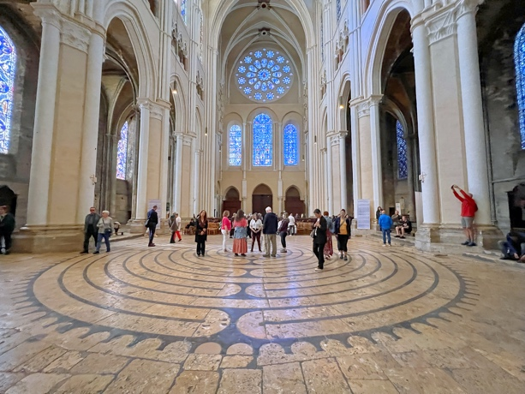

Chartres Cathedral has endured for centuries—through wars, upheaval, and change—and in that endurance it speaks quietly of resilience. Built in the thirteenth century, it drew on the most advanced scientific, architectural, and artistic knowledge of its time: a collective achievement that still inspires awe at what people can imagine and create together. Raised to lift the spirit, the cathedral offers beauty as a shared experience—a place where light, stone, and craftsmanship invite reflection, inspiration, and wonder. Today, as a UNESCO World Heritage site, Chartres continues to stand as a symbol of peace and international friendship.
The American Friends of Chartres, whose mission is both simple and expansive—to spread the radiance of Chartres: its beauty, cultural inheritance, and enduring capacity to inspire hope and love—are honored to present this traveling photographic exhibition by Jill Geoffrion. The exhibit pairs images of the cathedral’s original medieval labyrinth with photographs of contemporary Chartres-style labyrinths built and walked around the world, with particular attention to communities shaped by upheaval, displacement, and loss.
Visitors are invited to enter a doorway into a path that is at once a cultural treasure and, for many, a living spiritual practice. The Wayzata Community Church on-site Peace Labyrinth offers the opportunity to take the next step—embodying quiet attention, reflection, and prayer—while opening space for healing, resilience, and hope.
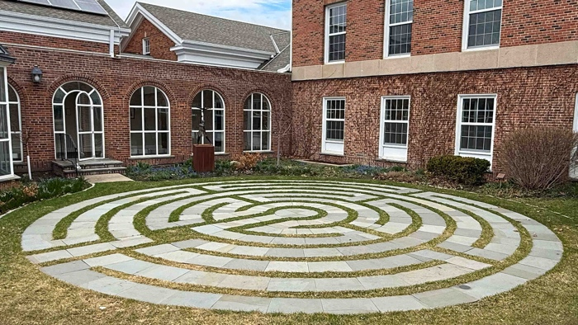
Debuting at Wayzata Community Church (125 Wayzata Blvd. E, Wayzata, MN 55391)in Minnesota in summer 2026, the exhibition marks the 20th anniversary of American Friends of Chartres.
Artist Bio
The Rev. Jill K. H. Geoffrion, Ph.D., is a professional photographer and guide at Chartres Cathedral. A co-founder of Faith, Hope, and Love Global Ministries, she is known for building, walking, and documenting Chartres-style labyrinths around the world.

